# Social media posts with supporting images

Please scroll through the posts below and pick what may be suitable for your audience and channels. The images (tiles which are at 1080 x1080px for social media) can be interchanged to suit your purposes and there are a few extra to choose from at the bottom.

Posts are:

1. We are proud members of The Biosecurity Business Pledge
2. Proudly supporting the Biosecurity Business Pledge’s Awareness Month
3. Help stop this pest getting into NZ
4. Let’s talk about Foot and mouth disease (FMD)
5. Biosecurity alert: understanding & preventing high pathogenicity avian influenza (HPAI)
6. Ant-tastic alert
7. Calling all business leaders
8. Good biosecurity risk management is key to a resilient and thriving economy
9. What is business biosecurity?
10. The role of all businesses in lowering biosecurity risks
11. Strengthening our borders - the first line of defence
12. Biosecurity risk reduction tips for business travel
13. Thwarting sneaky threats
14. New biosecurity training module available for any business

### We are proud members of The Biosecurity Business Pledge

We believe in playing our part in keeping unwanted pests and diseases out of New Zealand. It simply makes good business sense.

Good biosecurity protects our business, New Zealand’s unique natural environment, our economy and way of life.

Do you know what to do if you find an unusual insect at your business or in your home garden that you suspect might be a biosecurity risk?

Photograph it and catch it if it is safe to do so and report it to the Biosecurity New Zealand hotline 0800 80 99 66.

To learn more about the Pledge and the support and tools it can give your business  <https://www.thisisus.nz/biosecurity-business/biosecurity-business-pledge/>

***#biosecuritymatters #AugustBiosecurityAwarenessMonth***

### Proudly supporting the Biosecurity Business Pledge’s Awareness Month

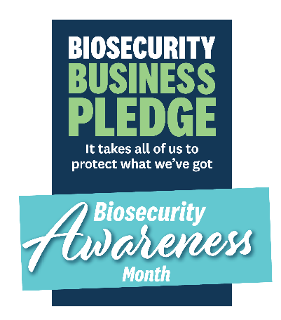The Biosecurity Business Pledge is a membership organisation that supports and encourages businesses to play a proactive role in a biosecurity system that successfully protects New Zealand’s unique national environment, economy and way of life.

We are proud to be members and encourage everyone to play their understanding the importance of biosecurity and what to do if you find something that you think is suspect.

There are a number of resources such as unwanted pest posters that are downloadable from the [tools and templates section](https://debbieteale.cmail20.com/t/y-i-mtyito-l-y/) on the Pledge website. Take a look today and help keep our nation free of unwanted pests and diseases.

To learn more about the Pledge <https://www.thisisus.nz/biosecurity-business/biosecurity-business-pledge/> If your organisation is interested in becoming a Biosecurity Business Pledge member contact us today through the website or email [Ruth@gngroup.nz](mailto:Ruth@gngroup.nz)

***#biosecuritymatters #AugustBiosecurityAwarenessMonth***

### Help stop this pest getting into NZ

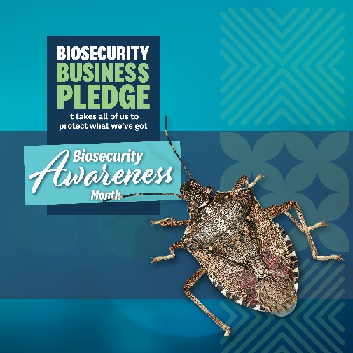

Meet the brown marmorated stink bug (BMSB), an agricultural, horticultural and social pest that, if established, could have serious impacts on our economy as well as in our homes. Recognisable by its shield-like shape, BMSB release a foul-smelling odour when disturbed.

As a proud member of the Biosecurity Business Pledge, we invite you to download the Pledge’s BMSB poster at [www.thisisus.nz/biosecurity-business/biosecurity-business-pledge/tools-and-templates/](http://www.thisisus.nz/biosecurity-business/biosecurity-business-pledge/tools-and-templates/) and use them in your workplace to spread awareness and support ensuring this bug cannot establish here.

To learn more about the Pledge and the support and tools it can give your business  <https://www.thisisus.nz/biosecurity-business/biosecurity-business-pledge/> If your organisation is interested in becoming a Biosecurity Business Pledge member contact us today through the website or email [Ruth@gngroup.nz](mailto:Ruth@gngroup.nz)

***#biosecuritymatters #AugustBiosecurityAwarenessMonth #BMSB***

Let’s talk about Foot and mouth disease (FMD)

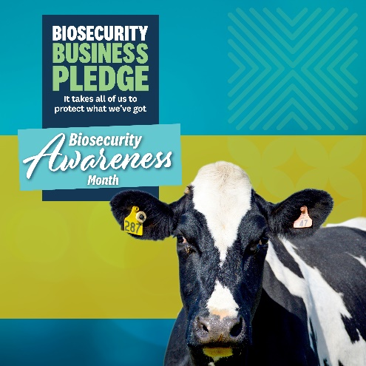

FMD is a highly contagious viral disease that infects cloven-hoofed animals. An outbreak in New Zealand would seriously affect farmers, rural communities, primary industries and the economy. It is not currently in New Zealand, and we need to keep it that way.

As a proud member of the Biosecurity Business Pledge, we invite you to download the Pledge’s FMD poster at [www.thisisus.nz/biosecurity-business/biosecurity-business-pledge/tools-and-templates/](http://www.thisisus.nz/biosecurity-business/biosecurity-business-pledge/tools-and-templates/) and use them in your workplace to spread awareness and support ensuring we keep FMD out of Aotearoa.

To learn more about the Pledge and the support and tools it can give your business  <https://www.thisisus.nz/biosecurity-business/biosecurity-business-pledge/> If your organisation is interested in becoming a Biosecurity Business Pledge member contact us today through the website or email [Ruth@gngroup.nz](mailto:Ruth@gngroup.nz)

***#biosecuritymatters #AugustBiosecurityAwarenessMonth #FMD***

Biosecurity alert: understanding & preventing high pathogenicity avian influenza (HPAI)

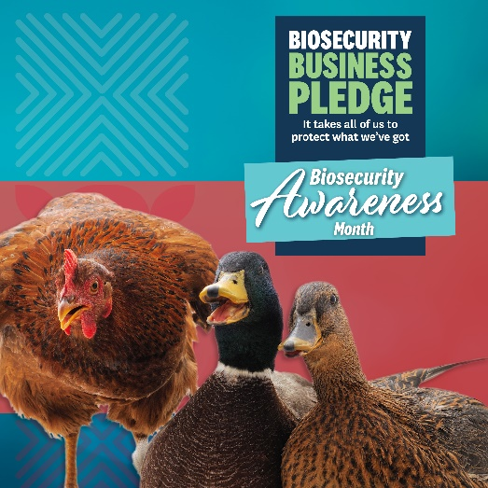You may have heard recent reports about HPAI in the media. New Zealand has never had a case of HPAI, but it is important to understand the signs and keep an eye out for it. This severe viral disease that affects both domestic poultry and wild birds is highly contagious. An outbreak could devastate the poultry industry, impacting our food supply and economy.

As a proud member of the Biosecurity Business Pledge, we invite you to download the Pledge’s HPAI poster at [www.thisisus.nz/biosecurity-business/biosecurity-business-pledge/tools-and-templates](http://www.thisisus.nz/biosecurity-business/biosecurity-business-pledge/tools-and-templates) and use them in

your workplace to spread awareness about the signs to look for.

To learn more about the Pledge and the support and tools it can give your

business  <https://www.thisisus.nz/biosecurity-business/biosecurity-business-pledge/> If your organisation is interested in becoming a Biosecurity Business Pledge member contact us today through the website or email [Ruth@gngroup.nz](mailto:Ruth@gngroup.nz)

***#biosecuritymatters #AugustBiosecurityAwarenessMonth #HPAI***

Ant-tastic alert

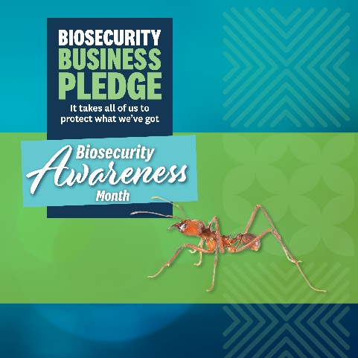

The red imported fire ant (RIFR) is a fiery pest known overseas for its painful sting as well as its potential to cause serious economic and environmental damage. We need to keep RIFR out of New Zealand.

As a proud member of the Biosecurity Business Pledge, we invite you to download the Pledge’s poster at [www.thisisus.nz/biosecurity-business/biosecurity-business-pledge/tools-and-templates](http://www.thisisus.nz/biosecurity-business/biosecurity-business-pledge/tools-and-templates) and use them in your workplace to raise awareness.

To learn more about the Pledge and the support and tools it can give your

business  <https://www.thisisus.nz/biosecurity-business/biosecurity-business-pledge/> If your organisation is interested in becoming a Biosecurity Business Pledge member contact us today through the website or email [Ruth@gngroup.nz](mailto:Ruth@gngroup.nz)

***#biosecuritymatters #AugustBiosecurityAwarenessMonth #RIFR***

### Calling all business leaders

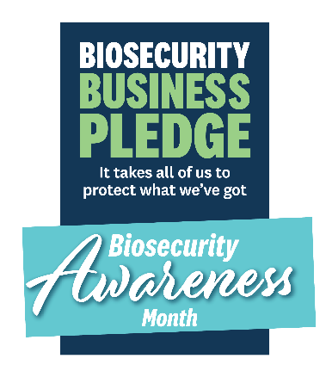

Biosecurity is about protecting your business, New Zealand’s unique natural environment, its economy and our way of life.

Directors have an obligation to be aware of all types of risks to a business and to ensure they’re appropriately managed. Biosecurity should be considered an equal part of good business risk management alongside your approach to health and safety at work, and food safety, with potentially similar levels of legal liability for companies and directors.

Your business may have specific biosecurity requirements under the Biosecurity Act 1993 and its regulations that outline compliance measures for businesses to operate safely.

We are members of The Biosecurity Business Pledge, a membership organisation that supports and encourages businesses to play a proactive role in a biosecurity system.

The Pledge has guidance for governors and CEs to help you protect your business and manage down biosecurity risks.

Read the guidance here <https://www.thisisus.nz/biosecurity-business/biosecurity-business-pledge/>

If your organisation is interested in becoming a Biosecurity Business Pledge member contact us today through the website or email [Ruth@gngroup.nz](mailto:Ruth@gngroup.nz)

***#biosecuritymatters #AugustBiosecurityAwarenessMonth***

### 

### Good biosecurity risk management is key to a resilient and thriving economy

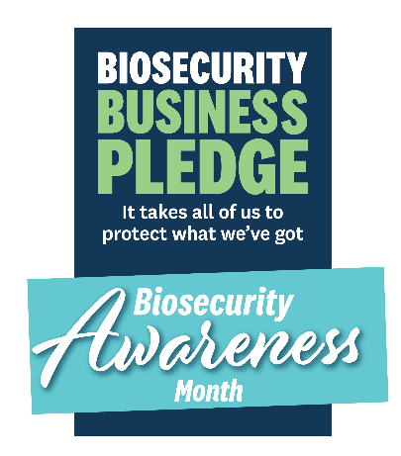

New Zealand’s biosecurity system underpins trade, primary production and biodiversity – it helps guard our way of life. The biosecurity system allows New Zealand to safely move animals, plants and food within New Zealand and to and from other countries.

The risk to our natural biosecurity increases in-line with the increasing movements of cargo, passengers, craft and mail into our country. The economic cost and disruption that would occur if something like the brown marmorated stink bug or foot and mouth disease found their way into New Zealand would be devastating to us all.

The Biosecurity Business Pledge is a membership organisation that supports and encourages businesses to play a proactive role in the biosecurity system.

There are a number of resources such as unwanted pest posters that are downloadable from the [tools and templates section](https://debbieteale.cmail20.com/t/y-i-mtyito-l-y/) on the Pledge website. Take a look today and help keep our nation free of unwanted pests and diseases.

To learn more about the Pledge <https://www.thisisus.nz/biosecurity-business/biosecurity-business-pledge/> If your organisation is interested in becoming a Biosecurity Business Pledge member contact us today through the website or email [Ruth@gngroup.nz](mailto:Ruth@gngroup.nz)

***#biosecuritymatters #AugustBiosecurityAwarenessMonth***

### What is ‘business biosecurity’?

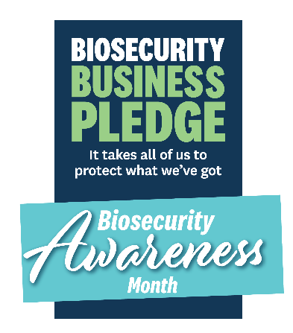

Business biosecurity is about the management of biosecurity risks and the specific actions that individual businesses can take to minimise and prevent pests and diseases from getting into New Zealand.

If something gets here, we call it an incursion and that could disrupt your business, someone else’s, our ability to trade internationally or even be devastating to a region or the economy. Business biosecurity also refers to the practice of helping stop the domestic spread of a pest or disease.

The Biosecurity Business Pledge is a membership organisation that supports and encourages businesses to play a proactive role in the biosecurity system.

There are a number of resources such as unwanted pest posters that are downloadable from the [tools and templates section](https://debbieteale.cmail20.com/t/y-i-mtyito-l-y/) on the Pledge website. Take a look today and help keep our nation free of unwanted pests and diseases.

To learn more about the Pledge <https://www.thisisus.nz/biosecurity-business/biosecurity-business-pledge/> If your organisation is interested in becoming a Biosecurity Business Pledge member contact us today through the website or email [Ruth@gngroup.nz](mailto:Ruth@gngroup.nz)

***#biosecuritymatters #AugustBiosecurityAwarenessMonth***

### The role of all businesses in lowering biosecurity risks

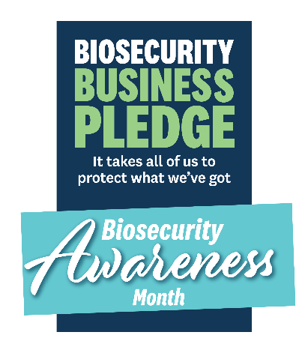

There are four risk pathways into our country – cargo, passengers, craft and mail – and business activity can include any one of these in and out of country and around our nation. These movements are considered pathways for the movement of pests and diseases. It is best for New Zealand if we manage as much risk offshore.

The Biosecurity Business Pledge is a membership organisation that supports and encourages businesses to play a proactive role in the biosecurity system.

There are a number of resources such as unwanted pest posters that are downloadable from the [tools and templates section](https://debbieteale.cmail20.com/t/y-i-mtyito-l-y/) on the Pledge website. Take a look today and help keep our nation free of unwanted pests and diseases.

To learn more about the Pledge <https://www.thisisus.nz/biosecurity-business/biosecurity-business-pledge/> If your organisation is interested in becoming a Biosecurity Business Pledge member contact us today through the website or email [Ruth@gngroup.nz](mailto:Ruth@gngroup.nz)

***#biosecuritymatters #AugustBiosecurityAwarenessMonth***

### Strengthening our borders - the first line of defence

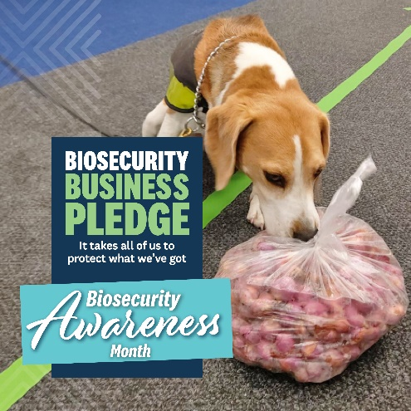Biosecurity New Zealand works with travellers, industry, importers and other organisations to keep unwanted pests and diseases from entering Aotearoa. Biosecurity inspectors actively manage biosecurity risks and are ready to respond if a pest or disease arrives.

Passengers arriving in the country enter at a ‘Place of First Arrival (PoFA)’ such as an airport have the chance to dispose of any risk goods in amnesty bins before passing through the biosecurity processing area.

If you are travelling overseas or have visitors coming, be sure to get familiar with entry requirements that protect our economy, our environment and our way of life - <https://www.mpi.govt.nz/bring-send-to-nz/bringing-and-posting-items-to-nz/how-to-declare-items-when-arriving-in-nz/>

***#biosecuritymatters #AugustBiosecurityAwarenessMonth***

### Biosecurity risk reduction tips for business travel

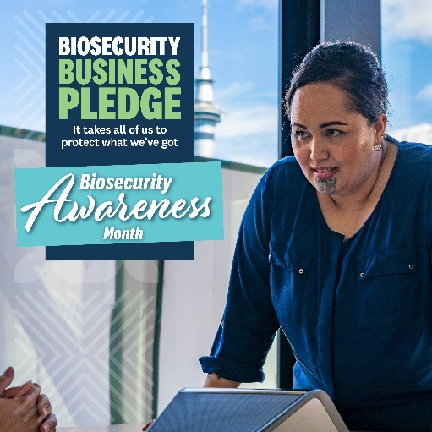Biosecurity Business Pledge member, Fonterra, shared its key biosecurity principles for their corporate travellers which aim to reduce the spread of pests and diseases that impact animals and feed crops. This is vital to help secure strong and thriving rural communities for future generations.

Have a look at their guidelines that reduce risk associated with travel - [www.thisisus.nz/assets/Business/Business-Pledge/Tools-and-templates/Biosecurity_Wallet_Final.pdf](http://www.thisisus.nz/assets/Business/Business-Pledge/Tools-and-templates/Biosecurity_Wallet_Final.pdf)

***#biosecuritymatters #AugustBiosecurityAwarenessMonth***

### Thwarting sneaky threats

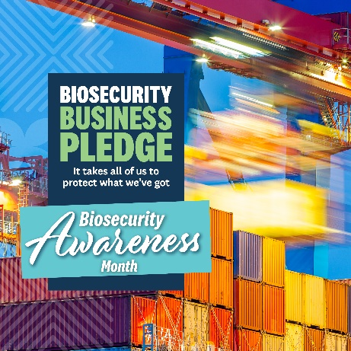

If you are an importer of goods, you’ll be aware of legal responsibilities and regulations that protect the health and safety of all New Zealanders as well as safeguard our economy. New pests and diseases can impact agriculture and horticultural production, forestry, and tourism as well as human health. They can also affect New Zealand's trade in international markets.

Invasive pests can hide in all sorts of goods and packing materials. Biosecurity is a shared responsibility. By staying vigilant and following import controls, we can protect our

economy and unique environment.

Spread awareness of these strict controls during Biosecurity Awareness Month with your network to help others understand their importance - [www.mpi.govt.nz/import/importing-into-nz-how-it-works/importing-process/](http://www.mpi.govt.nz/import/importing-into-nz-how-it-works/importing-process/)

***#biosecuritymatters #AugustBiosecurityAwarenessMonth***

### New biosecurity training module available for any business

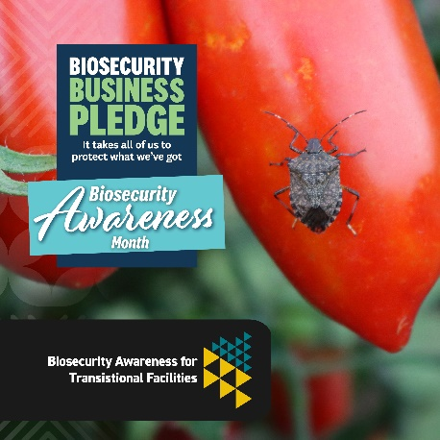

Designed to be accessible and beneficial for everyone but especially if you run a Transitional Facility (TF), this new Biosecurity New Zealand training module will help build an understanding about what biosecurity is and what actions need to be taken if something out of the ordinary is found - [www.mpi.govt.nz/resources/mpi-biosecurity-awareness-for-transitional-facilities/client/dist/story.html](http://www.mpi.govt.nz/resources/mpi-biosecurity-awareness-for-transitional-facilities/client/dist/story.html)

Empower your teams with the knowledge and skills that contribute to our biosecurity efforts.

***#biosecuritymatters #AugustBiosecurityAwarenessMonth***

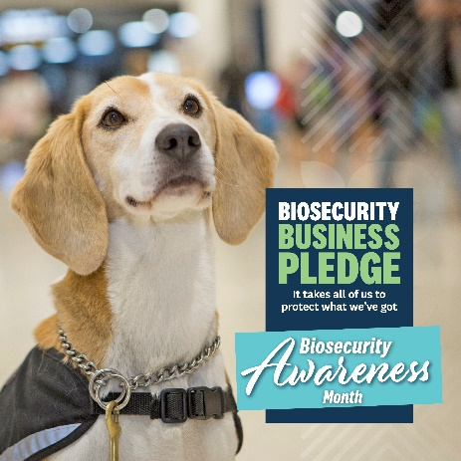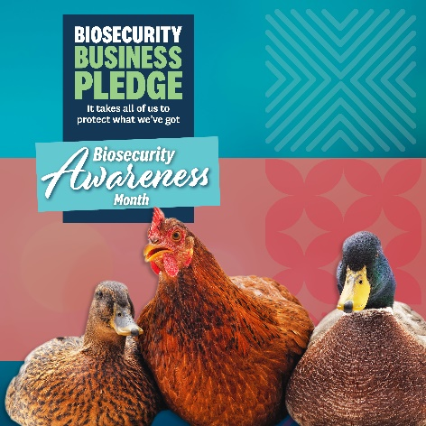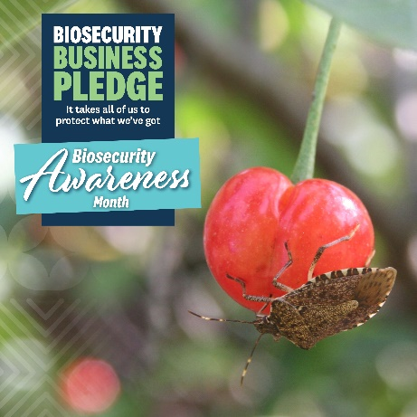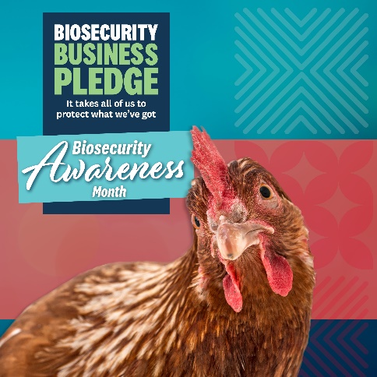Extra images

