Social media posts with supporting images

Please scroll through the posts below and pick what may be suitable for your audience and channels. The images can be interchanged to suit your purposes and there are a few extra to choose from at the bottom.

Jpgs of the social media tiles at 1080 x1080px are also available.

Posts are:

- We are proud members of The Biosecurity Business Pledge
- Proudly supporting the Biosecurity Business Pledge’s Awareness Month
- Help stop this pest getting into NZ
- Let’s talk about foot & mouth disease (FMD)
- Biosecurity alert: understanding & preventing high pathogenicity avian influenza (HPAI) H5N1
- Ant-tastic alert
- Calling all business leaders
- Good biosecurity risk management is key to a resilient and thriving economy
- What is business biosecurity?
- The role of all businesses in lowering biosecurity risks
- Strengthening our borders - the first line of defence
- Biosecurity risk reduction tips for business travel
- Thwarting sneaky threats
- Biosecurity training module available for any business

We are proud members of The Biosecurity Business Pledge


We believe in playing our part in keeping unwanted pests and diseases out of New Zealand. It simply makes good business sense.

Good biosecurity protects our business, New Zealand’s unique natural environment, our economy and way of life. Do you know what to do if you find an unusual insect at your business or in your home garden that you suspect might be a biosecurity risk?

Photograph it and catch it if it is safe to do so and report it to the Biosecurity New Zealand hotline 0800 80 99 66.

Learn more about the Pledge and the support & tools it can give your business.

#biosecuritymatters #AugustBiosecurityAwarenessMonth

Proudly supporting the Biosecurity Business Pledge’s Awareness Month
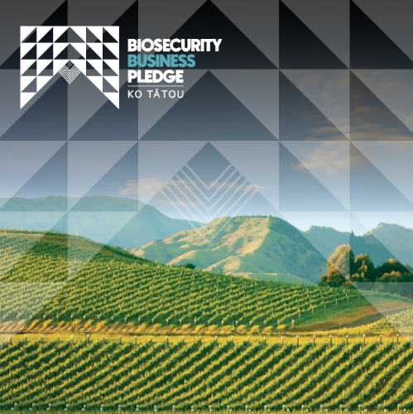
The Biosecurity Business Pledge is a membership organisation that supports and encourages businesses to play a proactive role in a biosecurity system that successfully protects New Zealand’s unique national environment, economy and way of life.

We are proud to be members and encourage everyone to play their part in understanding the importance of biosecurity and what to do if you find something that you think is suspect.

There are a number of resources such as unwanted pest posters that are downloadable from the tools and templates section on the Pledge website. Take a look today and help keep our nation free of unwanted pests and diseases.

Learn more about the Pledge. If your organisation is interested in becoming a Biosecurity Business Pledge member contact us today through the website or email info@bbpledge.nz
#biosecuritymatters #AugustBiosecurityAwarenessMonth

Help stop this pest getting into NZ

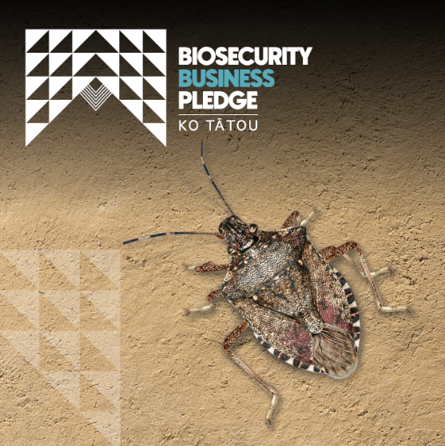
Meet the brown marmorated stink bug (BMSB), an agricultural, horticultural and social pest that, if established, could have serious impacts on our economy as well as in our homes. Recognisable by its shield-like shape, BMSB release a foul-smelling odour when disturbed.

As a proud member of the Biosecurity Business Pledge, we invite you to download the Pledge’s BMSB poster and use it in your workplace to spread awareness and support ensuring this pest cannot establish here.
Learn more about the Pledge and the support & tools it can give your business. If your organisation is interested in becoming a Biosecurity Business Pledge member contact us today through the website or email info@bbpledge.nz

#biosecuritymatters #AugustBiosecurityAwarenessMonth #BMSB

Let’s talk about foot & mouth disease (FMD)

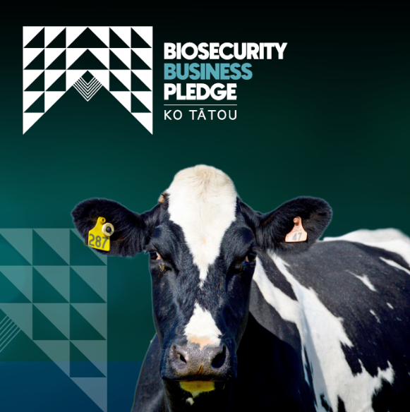
FMD is a highly contagious viral disease that infects cloven-hoofed animals. An outbreak in New Zealand would seriously affect farmers, rural communities, primary industries and the economy. It is not currently in New Zealand, and we need to keep it that way.

As a proud member of the Biosecurity Business Pledge, we invite you to download the Pledge’s FMD poster and use it in your workplace to spread awareness and support ensuring we keep FMD out of Aotearoa.

Learn more about the Pledge and the support and tools it can give your business. If your organisation is interested in becoming a Biosecurity Business Pledge member contact us today through the website or email info@bbpledge.nz

#biosecuritymatters #AugustBiosecurityAwarenessMonth #FMD

Biosecurity alert: understanding & preventing high pathogenicity avian influenza (HPAI) H5N1

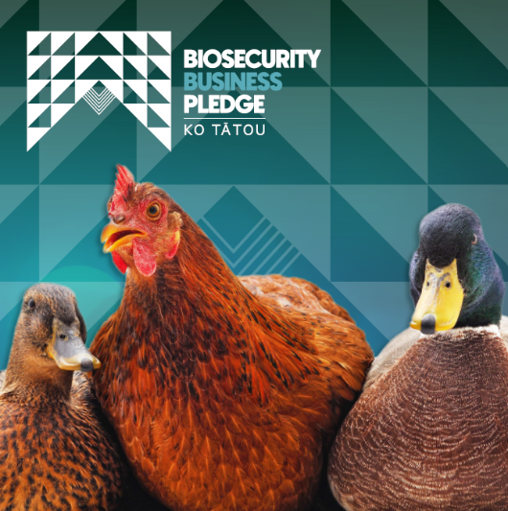
The H5N1 strain of HPAI – also known as bird flu – is spreading across the globe. While New Zealand, Australia and the South Pacific remain free of this disease, it is important to understand the signs and keep an eye out for it. HPAI H5N1 affects both domestic and wild birds and could severely impact our poultry industry if it reaches New Zealand.

As a proud member of the Biosecurity Business Pledge, we invite you to download the Pledge’s HPAI poster and use it in your workplace to spread awareness about the signs to look for.

Learn more about the Pledge and the support & tools it can give your
business. If your organisation is interested in becoming a Biosecurity Business Pledge member contact us today through the website or email info@bbpledge.nz

#biosecuritymatters #AugustBiosecurityAwarenessMonth #HPAI

Ant-tastic alert
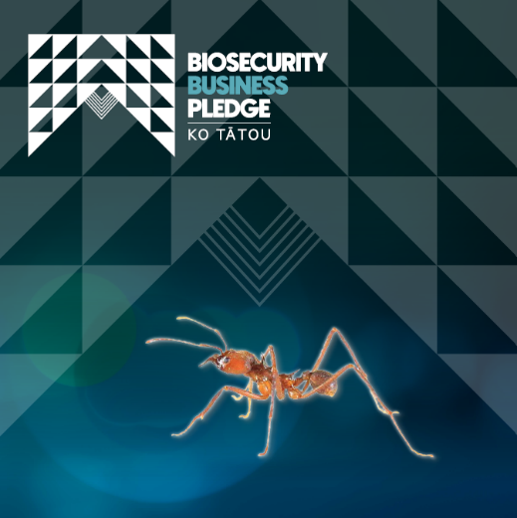
The red imported fire ant (RIFR) is a fiery pest known overseas for its painful sting as well as its potential to cause serious economic and environmental damage. We need to keep RIFR out of New Zealand.

As a proud member of the Biosecurity Business Pledge, we invite you to download the Pledge’s poster and use it in your workplace to raise awareness.

Learn more about the Pledge and the support & tools it can give your business. If your organisation is interested in becoming a Biosecurity Business Pledge member contact us today through the website or email info@bbpledge.nz

#biosecuritymatters #AugustBiosecurityAwarenessMonth #RIFR

Calling all business leaders

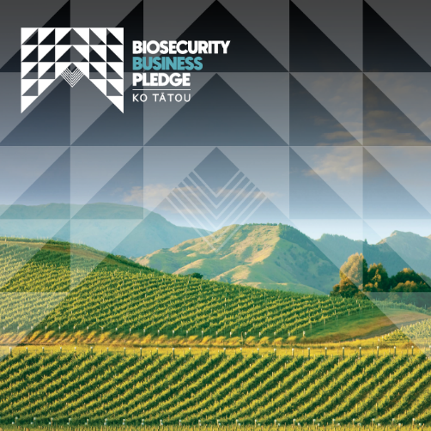
Biosecurity is about protecting your business, New Zealand’s unique natural environment, its economy and our way of life.

Directors have an obligation to be aware of all types of risks to a business and to ensure they’re appropriately managed. Biosecurity should be considered an equal part of good business risk management alongside your approach to health and safety at work, and food safety, with potentially similar levels of legal liability for companies and directors.

We are members of The Biosecurity Business Pledge, a membership organisation that supports and encourages businesses to play a proactive role in a biosecurity system.
The Pledge has guidance for governors and CEs to help you protect your business and manage down biosecurity risks. Read the guidance here.

If your organisation is interested in becoming a Biosecurity Business Pledge member contact us today through the website or email info@bbpledge.nz

#biosecuritymatters #AugustBiosecurityAwarenessMonth

Good biosecurity risk management is key to a resilient and thriving economy

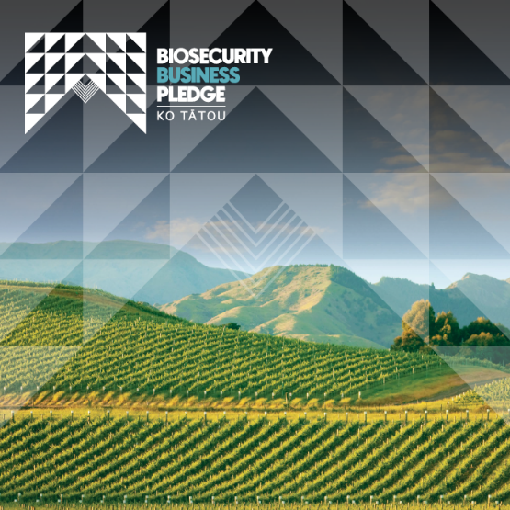
New Zealand’s biosecurity system underpins trade, primary production and biodiversity. The biosecurity system allows us to safely move animals, plants and food within New Zealand and to and from other countries.

The risk to our natural biosecurity increases in-line with the increasing movements of cargo, passengers, craft and mail into our country. The economic cost and disruption that would occur if something found its way into New Zealand would be devastating to us all.

The Biosecurity Business Pledge is a membership organisation that supports and encourages businesses to play a proactive role in the biosecurity system.

There are a number of resources such as unwanted pest posters that are downloadable from the tools and templates section on the Pledge website. Take a look today and help keep our nation free of unwanted pests and diseases.

Learn more about the Pledge. If your organisation is interested in becoming a Biosecurity Business Pledge member contact us today through the website or email info@bbpledge.nz
#biosecuritymatters #AugustBiosecurityAwarenessMonth

What is ‘business biosecurity’?
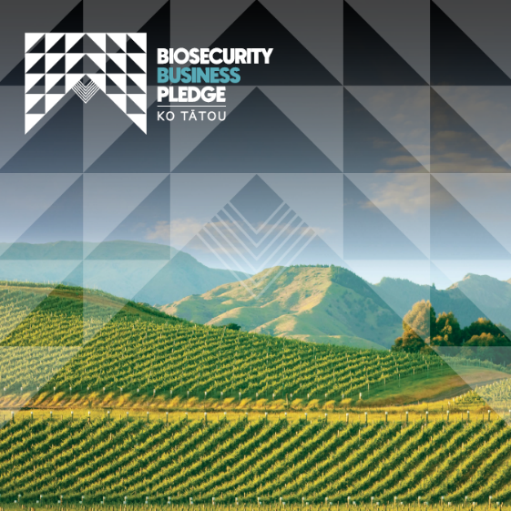
Business biosecurity is about the management of biosecurity risks and the actions that individual businesses can take to minimise and prevent pests and diseases from getting into New Zealand.

If something gets here, we call it an incursion and that could disrupt your business, someone else’s, our ability to trade internationally or even be devastating to a region or the economy. Business biosecurity also refers to the practice of helping stop the domestic spread of a pest or disease.

The Biosecurity Business Pledge is a membership organisation that supports and encourages businesses to play a proactive role in the biosecurity system.

There are a number of resources such as unwanted pest posters that are downloadable from the tools and templates section on the Pledge website. Take a look today and help keep our nation free of unwanted pests and diseases.

Learn more about the Pledge. If your organisation is interested in becoming a Biosecurity Business Pledge member contact us today through the website or email info@bbpledge.nz
#biosecuritymatters #AugustBiosecurityAwarenessMonth

The role of all businesses in lowering biosecurity risks

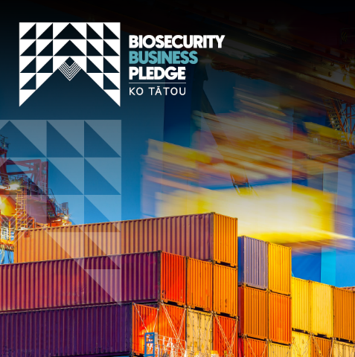
There are four risk pathways into our country – cargo, passengers, craft and mail – and business activity can include any one of these in and out of country and around our nation. These movements are considered pathways for the movement of pests and diseases. It is best for New Zealand if we manage as much risk offshore.

The Biosecurity Business Pledge is a membership organisation that supports and encourages businesses to play a proactive role in the biosecurity system.

There are a number of resources such as unwanted pest posters that are downloadable from the tools and templates section on the Pledge website. Take a look today and help keep our nation free of unwanted pests and diseases.

Learn more about the Pledge. If your organisation is interested in becoming a Biosecurity Business Pledge member contact us today through the website or email info@bbpledge.nz
#biosecuritymatters #AugustBiosecurityAwarenessMonth

Strengthening our borders - the first line of defence

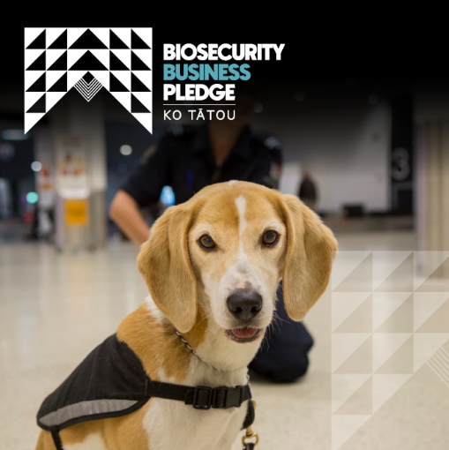
Biosecurity New Zealand works with travellers, industry, importers and other organisations to keep unwanted pests and diseases from entering Aotearoa. Biosecurity inspectors actively manage biosecurity risks and are ready to respond if a pest or disease arrives.

Passengers arriving in the country enter at a ‘Place of First Arrival (PoFA)’ such as an airport have the chance to dispose of any risk goods in amnesty bins before passing through the biosecurity processing area.

If you are travelling overseas or have visitors coming, be sure to get familiar with entry requirements that protect our economy, our environment and our way of life.

#biosecuritymatters #AugustBiosecurityAwarenessMonth

Biosecurity risk reduction tips for business travel

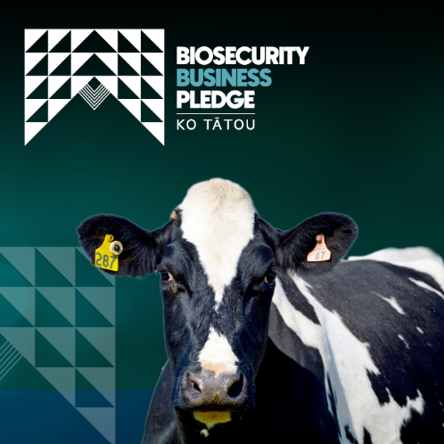
Biosecurity Business Pledge member, Fonterra, shared its key biosecurity principles for their corporate travellers which aim to reduce the spread of pests and diseases that impact animals and feed crops. This is vital to help secure strong and thriving rural communities for future generations.

Have a look at their guidelines that reduce risk associated with travel.(Scroll down to ‘Resources shared by Pledge members’.)

If your organisation is interested in becoming a Biosecurity Business Pledge member contact us today through the website or email info@bbpledge.nz

#biosecuritymatters #AugustBiosecurityAwarenessMonth

Thwarting sneaky threats
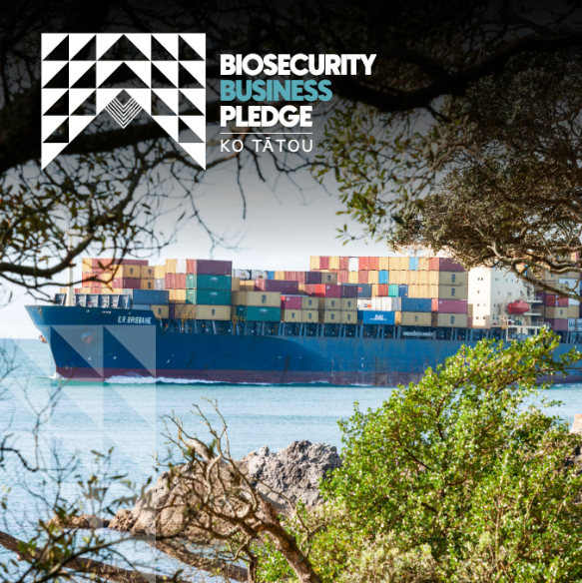
If you are an importer of goods, you’ll be aware of legal responsibilities and regulations that protect the health and safety of all New Zealanders as well as safeguard our economy. New pests and diseases can impact agriculture and horticultural production, forestry, and tourism as well as human health. They can also affect New Zealand's trade in international markets.

Invasive pests can hide in all sorts of goods and packing materials. Biosecurity is a shared responsibility. By staying vigilant and following import controls, we can protect our economy and
unique environment.

Spread awareness of these strict controls during Biosecurity Awareness Month with your network to help others understand their importance - www.mpi.govt.nz/import/importing-into-nz-how-it-works/importing-process/

#biosecuritymatters #AugustBiosecurityAwarenessMonth

Biosecurity training module available for any business

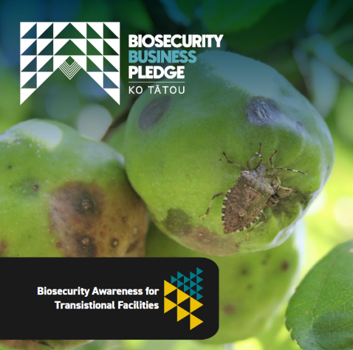
Designed to be accessible and beneficial for everyone but especially if you run a Transitional Facility (TF), this Biosecurity New Zealand training module will help build an understanding about what biosecurity is and what actions need to be taken if something out of the ordinary is suspected.

If your organisation is interested in becoming a Biosecurity Business Pledge member contact us today through the website or email info@bbpledge.nz

#biosecuritymatters #AugustBiosecurityAwarenessMonth

Extra images

